### Model Evaluation

Project Name: statistical machine learning TEAM ID: PNT2022TMID04163 approaches to liver disease prediction

Finally, we need to check to see how well our model is performing on the test data.

Evaluation Metrics:

accuracy_score of SVM is

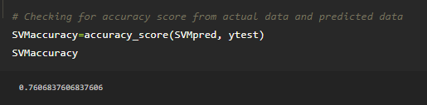

accuarcy_score of Random forest classification is

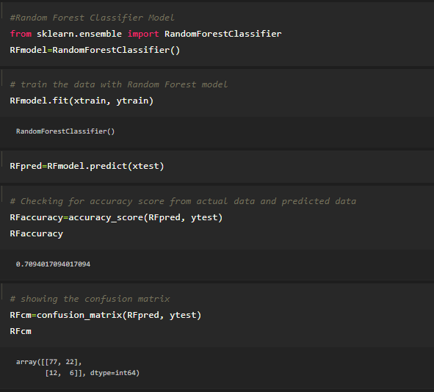

As we can see that the accuracy_score of the Support vector machine is higher compare to KNN and Random forest algorithms, we are proceeding with the support vector machine model.